EXPERIMENT- 40
Draw Rectangular Shape and Extract Objects
Aim
To write a Python code to draw rectangular shapes around detected objects and extract objects from the image using OpenCV.
Code
from google.colab import files
import cv2
import numpy as np
from google.colab.patches import cv2_imshow
uploaded = files.upload()
image_path = list(uploaded.keys())[0]
image = cv2.imread(image_path)
gray = cv2.cvtColor(image,cv2.COLOR_BGR2GRAY)
_,thresh = cv2.threshold(gray,127,255,cv2.THRESH_BINARY)
contours,_ = cv2.findContours(
thresh,
cv2.RETR_EXTERNAL,
cv2.CHAIN_APPROX_SIMPLE
)
for contour in contours:
x,y,w,h = cv2.boundingRect(contour)
cv2.rectangle(image,(x,y),(x+w,y+h),(0,255,0),2)
extracted_object = image[y:y+h,x:x+w]
print("Extracted Object")
cv2_imshow(extracted_object)
print("Objects with Rectangles")
cv2_imshow(image)

Input & Output Image
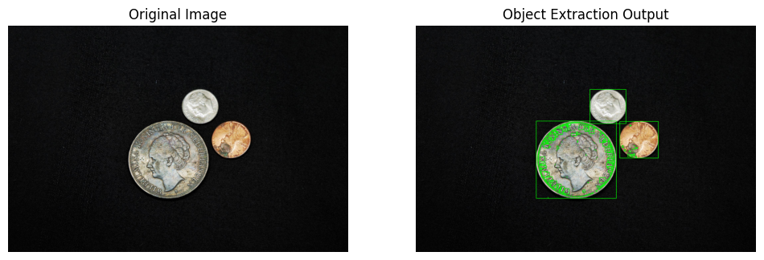
Result
Thus, the objects were successfully detected, extracted, and displayed using OpenCV.

